- Click on https://eforms.choateco.com/iFiller/iFiller.jsp?fref=55d51208d4d78de08af993a726018e86
- This form is needed to register for e-signature and access to submit pay applications electronically. Witnesses for GA Pay Applications must register as well.
- Fill in the boxes accordingly: date, tax id#, click Autofill. A pop up window containing all active vendors with the tax id# will open. Select the vendor by clicking on the blue text.

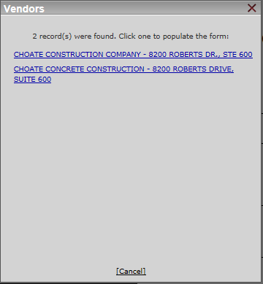

- Fill in the User Info box accordingly. Keep username and password in a safe location for future reference.
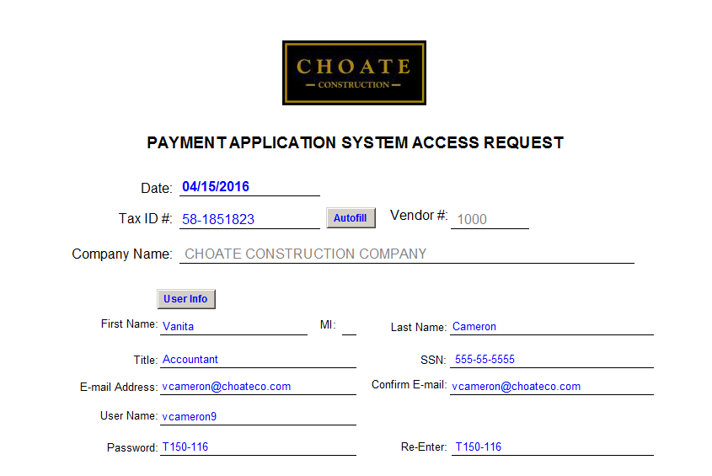

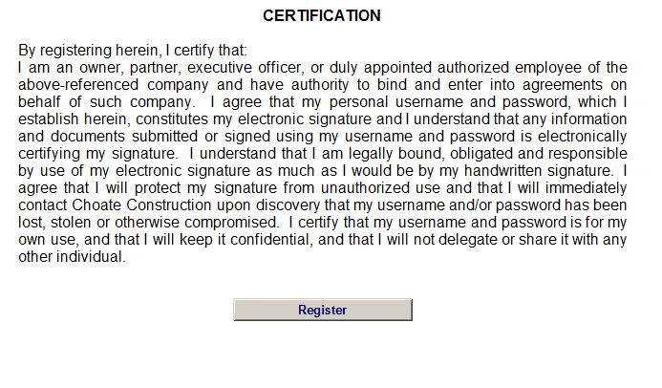
- Click Register. Click Ok. Close out of the form. You have now registered for e-signature. Please notate your username and password as you will need this to access pay application and submit it for payment.
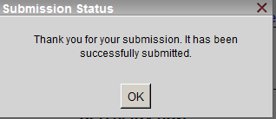
- Once access is granted you will receive the below email.

